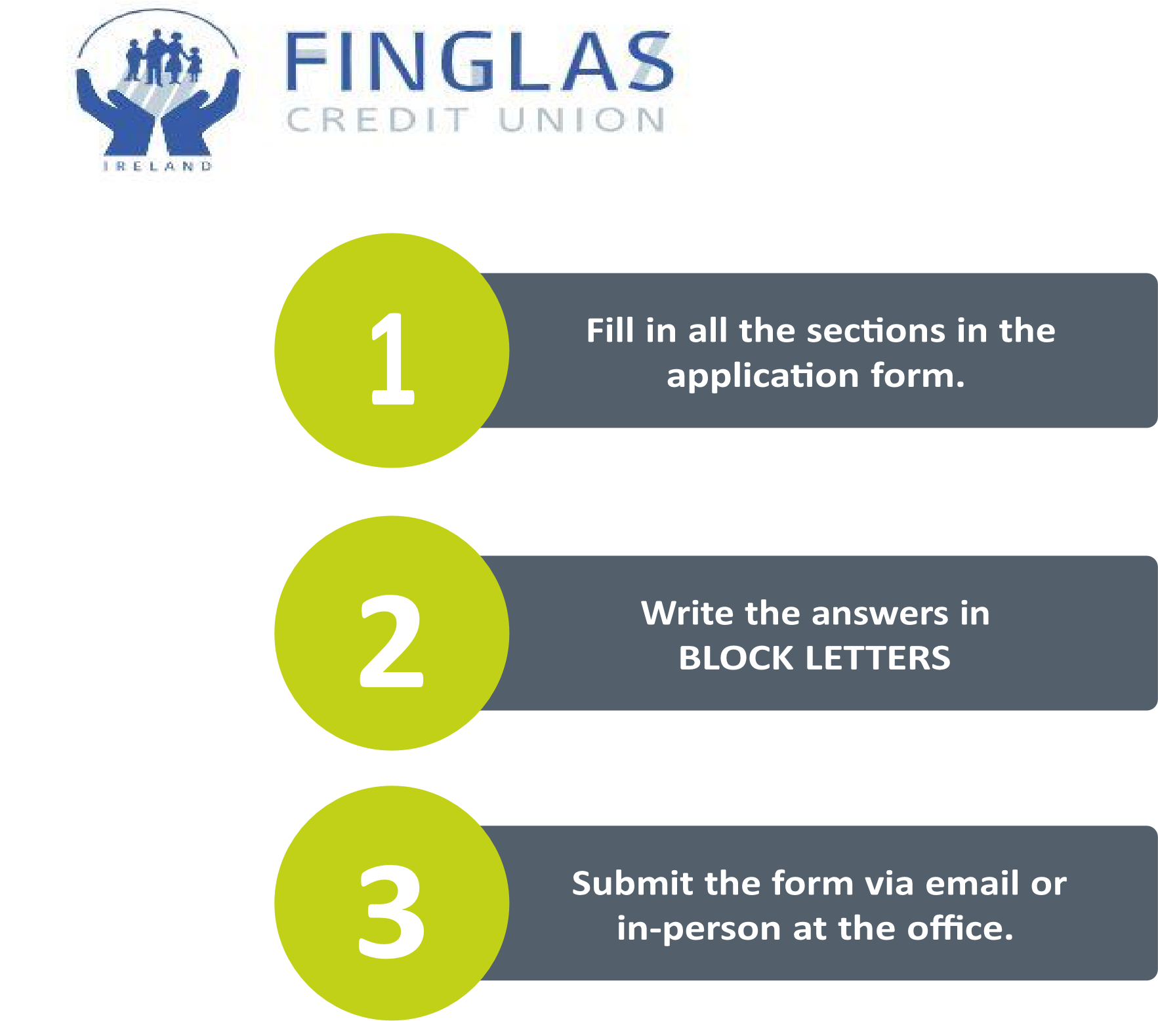

**CONTACT DETAILS:**

|  |  |
| --- | --- |
| Name of Applicant: |  |
| Address: |  |
| Contact  Number (Tel): |  |
| Email: |  |
| Name of Club / Organisation: |  |
| Role within organisation:  (if applicable) |  |
| Number of members:  (if applicable) |  |
| Website:  (If applicable) |  |
| Social Media Channels:  (if applicable) |  |

**Provide a brief description of your organisation/club?**

**Why do think your organisation/club should receive a donation from Finglas CU?**

**Have you received a donation from Finglas CU in the past?**

YES

NO

Not sure

*If you ticked “YES” please give a brief description of donations in the past.

**How much funding is required & how does the organisation/club intend to use the funding (equipment, event, etc.)?**

(if possible, please provide an approximate breakdown of project costs).



**Is the funding for a particular event?**



**How does the organisation/club intend to acknowledge Finglas CU?**

**Do you have a Credit Union or Bank Account to which the payment will be made?**



**Do you need any permission or approval for this project?**

Organisations/clubs that receive funding will be requested to display the Finglas Credit Union logo or banner during a sponsored event and agree that Finglas Credit Union can publicise material related to the sponsorship/event on social media pages, website, local newspaper or in email newsletters.

For full details, please see the terms & conditions.

If you have any questions, please send us an email, or give us a call.



Phone: 01-834 3193

Email: brian@finglascu.ie

Address: Seamus Ennis Road, Finglas, Dublin 11

**Declaration:**

1. I declare that the information provided in this form is correct.
2. I confirm that I have read & agree with the Terms & Conditions for the Community Fund outlined in this form.
3. I permit to have my personal data processed for the purpose of applying for this funding.

Signature

Position held

Date

**Terms & Conditions of the Community Fund:**

1. All applications are to be made via a completed Application Form with any supporting documents which may be required.
2. To be eligible, applicants must be located within our Common Bond.
3. Only groups or organisations will be considered. (Finglas Credit Union does not sponsor individuals).
4. All applicants for sponsorship will be notified in writing of the outcome of their application.
5. Finglas Credit Union does not guarantee recurring sponsorship year-to-year. Each applicant can reapply for sponsorship, if required on an annual basis in each financial year.
6. All applications must state how Finglas Credit Union will be represented through its sponsorship. The organisation must also demonstrate what benefits Finglas Credit Union and our community will get through the sponsorship of their organisation.
7. Finglas Credit Union requests that any sponsored organisation publish on their website, social media pages or in the local papers a photograph/brief statement in recognition of the contribution made by Finglas Credit Union.
8. All sponsorships are subject to agreement that Finglas Credit Union can publicise on the social media, internet and any publication Finglas Credit Union so chooses.
9. Finglas Credit Union requests that any sponsored organisation display the credit union logo and Finglas Credit Union’s banner during a sponsored event. Finglas Credit Union will provide a credit union logo and banner where necessary.
10. Finglas Credit Union requests that all sponsored organisations provide material showing how Finglas Credit Union was represented (photographs, copies of event brochures/adverts, printed items, copy of article in a newspaper etc).
11. Finglas Credit Union reserves the right to use the name of a sponsored organisation and any material provided for promotional purposes on our website, social media, AGM booklet, and local papers.
12. Failure to adhere to the terms and conditions could preclude the organisation from getting further sponsorship from Finglas Credit Union.
13. The decision taken by the Board of Directors on all applications is final and no correspondence will be entered into.